EXPERIMENT 3

AIM:
MATLAB-Based Modeling of VSB Modulator and Demodulator for Analog Television Communication Applications.

SOFTWARE REQUIRED:
MATLAB Simulink

PROGRAM:
Clc; clear; close all;
Fs=100000;
T=0:1/fs:0.02;
Fm=500; fc=5000;
M=cos(2*pi*fm*t);
C=cos(2*pi*fc*t);

% DSB-SC Modulation
Dsb=m.*c;

% VSB Modulation using low-pass filter
[b,a]=butter(4,0.6);
Vsb=filter(b,a,dsb);

% Demodulation
D=2*vsb.*c;
[b2,a2]=butter(4,2*fm/(fs/2));
Rec=filter(b2,a2,d);
Rec=rec/max(abs(rec));

Figure;
Subplot(5,1,1);
Plot(t,m); title(‘Message Signal’); grid on;

Subplot(5,1,2);
Plot(t,c); title(‘Carrier Signal’); grid on;

Subplot(5,1,3);
Plot(t,dsb); title(‘DSB-SC Signal’); grid on;

Subplot(5,1,4);
Plot(t,vsb); title(‘VSB Signal’); grid on;

Subplot(5,1,5);
Plot(t,rec,’r’); title(‘Recovered Message’); grid on;
Xlabel(‘Time (s)’);
OUTPUT:
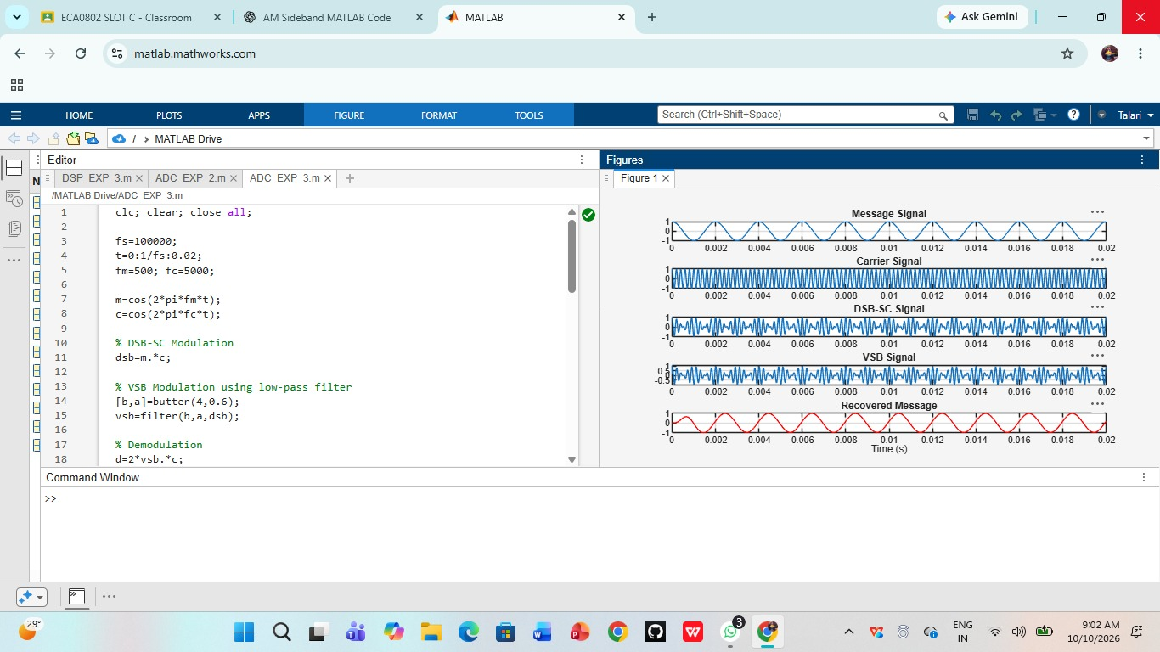

RESULT:
Thus, VSB modulation and demodulation for analog television communication was successfully demonstrated using MATLAB.

